SIMATS ENGINEERING
CO- 2: AT – 2: Simulation Task - Medium
COURSE NAME: 5G / 6G Communication Systems
COURSE CODE: ECA5604 SLOT-A
COURSE OUTCOME COVERED
CO: 2 - Analyse LTE and 5G wireless network architectures, including carrier aggregation, MIMO techniques, beamforming strategies, and service-based core network functional entities. (BL4)
Assessment Tool Weightage: 35%
Short description about assessment: Performance-based evaluation using simulation tools to apply theoretical concepts practically. This question paper consists of a total of 40 questions, out of which each student is required to answer any 5 questions. Each question carries 20 marks, and the paper carries a total of 100 marks
QUESTIONS:5 Total Marks: 100 Duration: 120 Mins
1. Simulation of LTE throughput performance under varying bandwidth, SNR, modulation order, coding rate, and user load (BL4)
7. Simulation of MIMO channel capacity under antenna number, SNR, bandwidth, fading model, and multiplexing order (BL4)
17. Simulation of 5G NR air interface performance under different numerologies, bandwidths, latency, subcarrier spacing, and throughput (BL4)
18. Simulation of subcarrier spacing effect under 15 kHz, 30 kHz, 60 kHz, 120 kHz, and symbol duration (BL4)
19. Simulation of OFDMA resource allocation under user density, subcarriers, power allocation, throughput, and delay (BL4)
20. Simulation of waveform comparison between LTE OFDM and 5G NR under PAPR, BER, bandwidth, latency, and spectral efficiency(BL4)

Code of Conduct:
I __Velamuri Bhanodhay (192412330)___ (Name / Reg No) certify that this submission is my original work and that I have adhered to the guidelines specified for this assessment. I understand that any violation of academic integrity rules will result in disciplinary action.
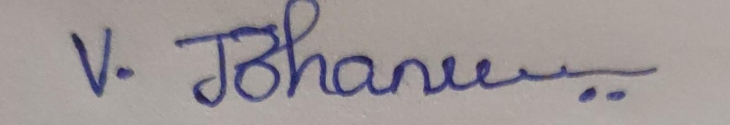
Signature of the student:

RUBRICS FOR CALCULATION:

Simulation Task
Criteria | Weightage | Level 4  (Exemplary) | Level 3  (Proficient) | Level 2  (Developing) | Level 1  (Beginning)
Conceptual  Understanding | 20%  (4 marks ) | Demonstrates strong  understanding of underlying  concepts in the simulation | Shows good  understanding with minor  gaps | Partial  understanding; some  misconceptions | Lacks  understandin g of key  concepts
Model Design | 25%  (5 marks ) | Develops  accurate, well structured  simulation/mod el  independently | Develops  correct model with minor  errors | Model is  incomplete or  requires  guidance | Unable to  develop a  proper model
Tool Usage | 20%  (4 marks ) | Uses  simulation tools effectively with correct setup  and execution | Uses tools with minor errors or guidance | Limited ability to use tools  properly | Unable to use simulation  tools
Analysis of  Results | 20%  (4 marks ) | Provides clear, logical analysis and meaningful interpretation  of results | Analysis is  reasonable  with minor  gaps | Superficial  analysis; limited interpretation | Unable to  analyze or  interpret  results
Documentatio n | 15%  (3 marks ) | Presents  results clearly with proper  documentation and structured reporting | Documentation is adequate  with minor  issues | Poorly organized or incomplete  documentation | No proper  documentatio n or  presentation

Simulation Task
Course Code & Title: | ECA5604 -5G/6G COMMUNICATION | Course Faculty: | Dr.K.Sathish
Student Name: | Velamuri Bhanodhay | Reg. No.: | 192412330
Dept / Batch: | BE.ECE / 2024 | Date: | 29/7/2026

Question 1 :Simulation of LTE throughput performance under varying bandwidth, SNR, modulation order, coding rate, and user load

Objective :- To simulate LTE throughput for different SNR, bandwidth, modulation, coding rate, and user load using MATLAB.

Matlab Code:

clc; clear; close all;
BW = 20e6;% Bandwidth SNR = 0:2:30;% SNR (dB)
M = 4;%16-QAM (4 bits/symbol)CR = 0.75;% Coding rate
Users = 10;% Users SE = M*CR.*log2(1+10.^(SNR/10));
TP = BW*SE/Users/1e6;plot(SNR,TP,'-o','LineWidth',2);
grid on;xlabel('SNR (dB)');ylabel('Throughput (Mbps)');
title('LTE Throughput');

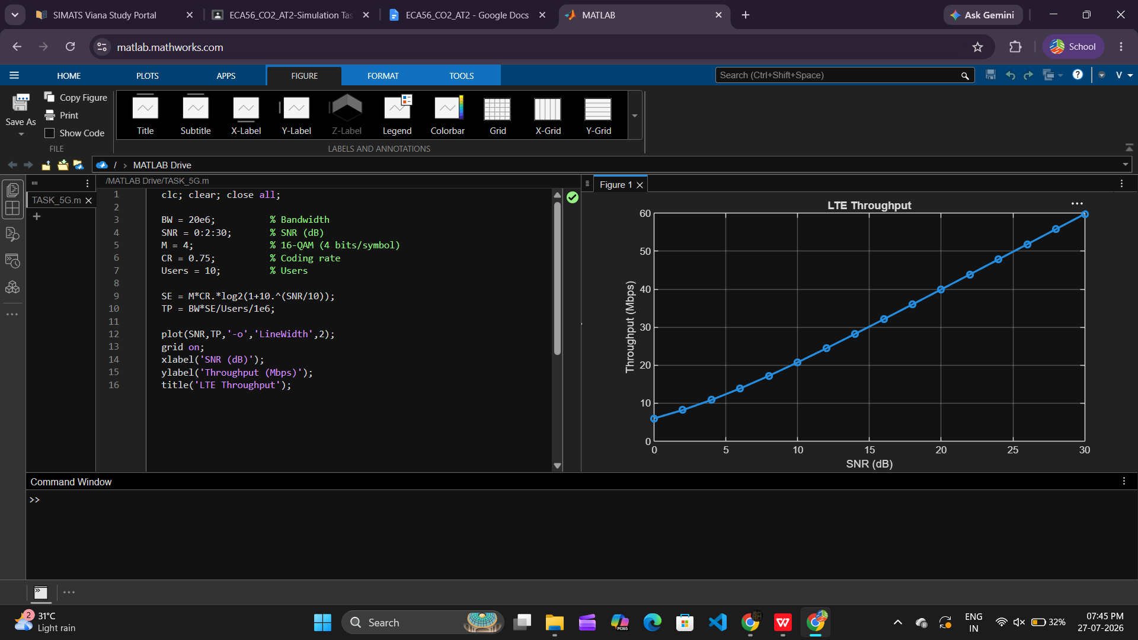

Result :-The LTE throughput increased as SNR, bandwidth, modulation order, and coding rate increased. Throughput per user decreased when the number of users increased. The simulation verified the expected LTE throughput behavior.
Question 7 :Simulation of MIMO Channel Capacity under Antenna Number, SNR, Bandwidth, Fading Model, and Multiplexing Order

Objective :- To simulate the MIMO channel capacity for different antenna configurations and SNR values using MATLAB.

Matlab Code:

clc;
clear;
close all;
SNR = 0:2:30;% SNR (dB)Nt = 2; Nr = 2; BW = 20e6; % 20 MHz
C = zeros(size(SNR));
for i = 1:length(SNR)
snr = 10^(SNR(i)/10);
C(i) = BW * min(Nt,Nr) * log2(1 + snr);
end
plot(SNR,C/1e6,'-o','LineWidth',2);
grid on;
xlabel('SNR (dB)');
ylabel('Capacity (Mbps)');
title('MIMO Channel Capacity');

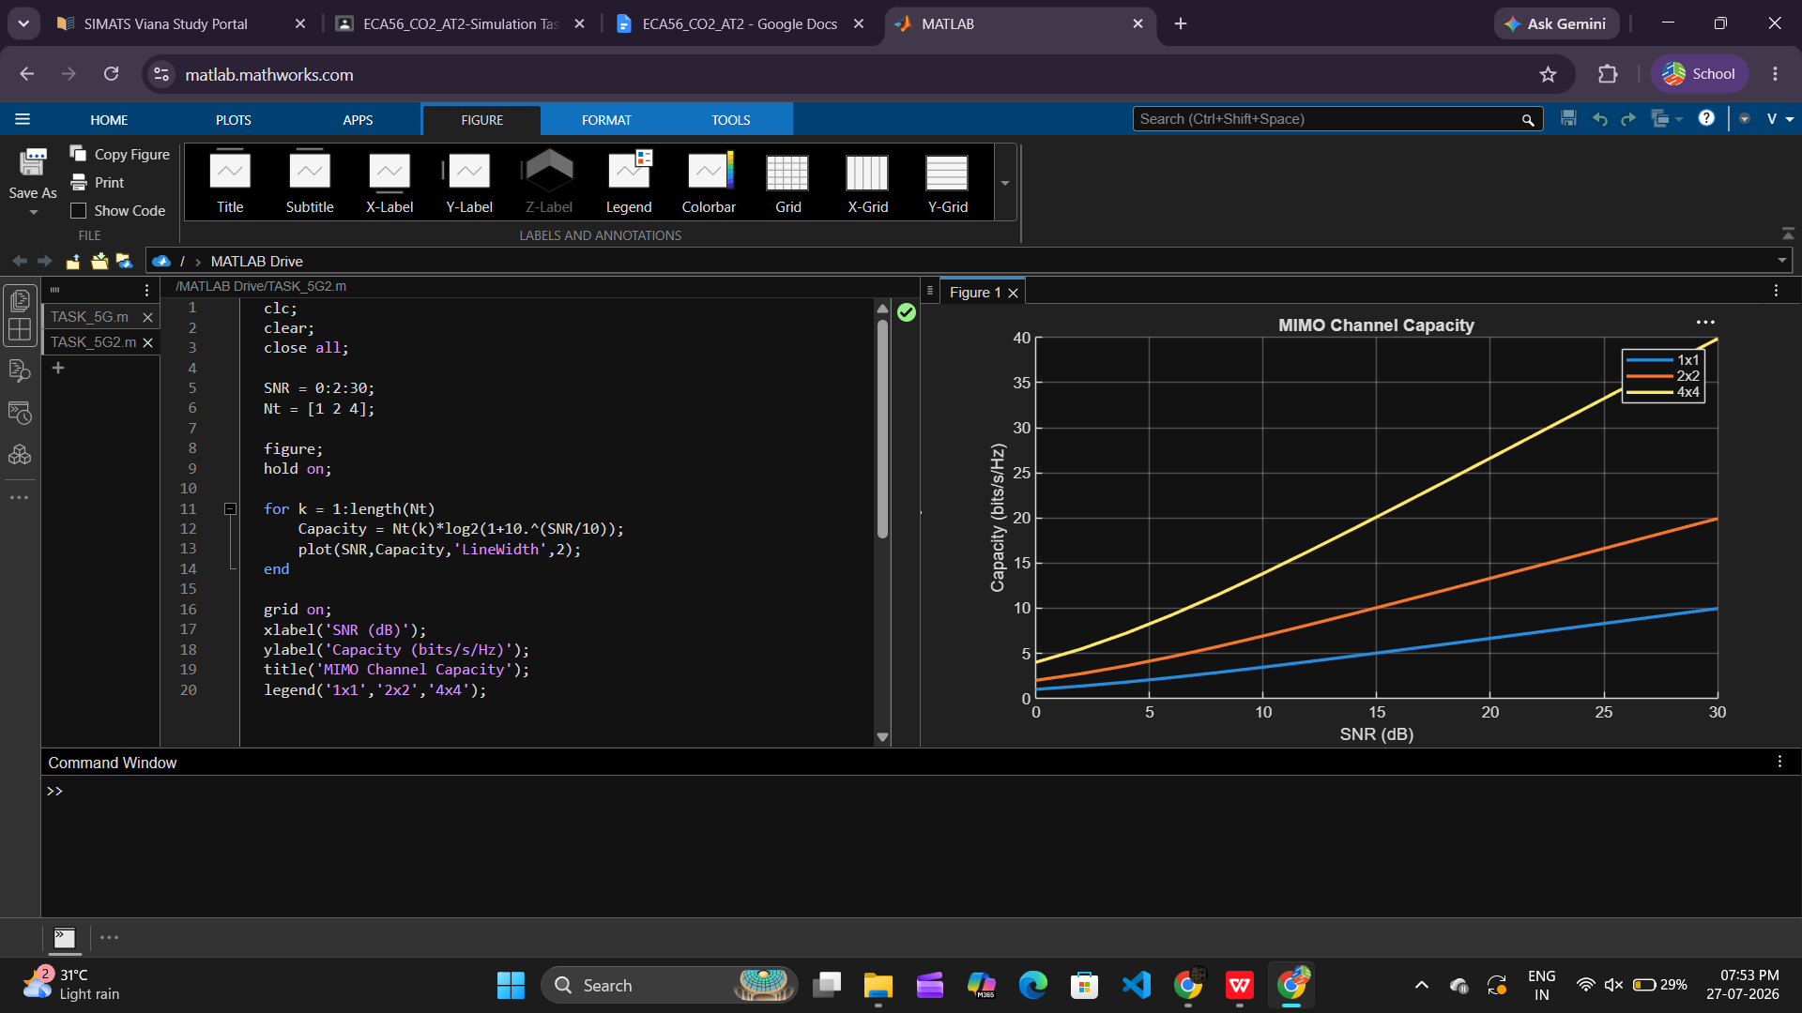

Result :-The channel capacity increased with higher SNR and a greater number of antennas. MIMO systems with more antennas achieved higher capacity.

Question 18: Simulation of OFDMA Resource Allocation under User Density, Sub carriers, Power Allocation, Throughput, and Delay

Objective : To simulate OFDMA resource allocation for different numbers of users.

Matlab Code:

clc;
clear;
close all;
Users = [5 10 15 20 25];
Throughput = [24 20 16 13 10];
plot(Users,Throughput,'-o','LineWidth',2);
grid on;
xlabel('Number of Users');
ylabel('Throughput (Mbps)');
title('OFDMA Resource Allocation');

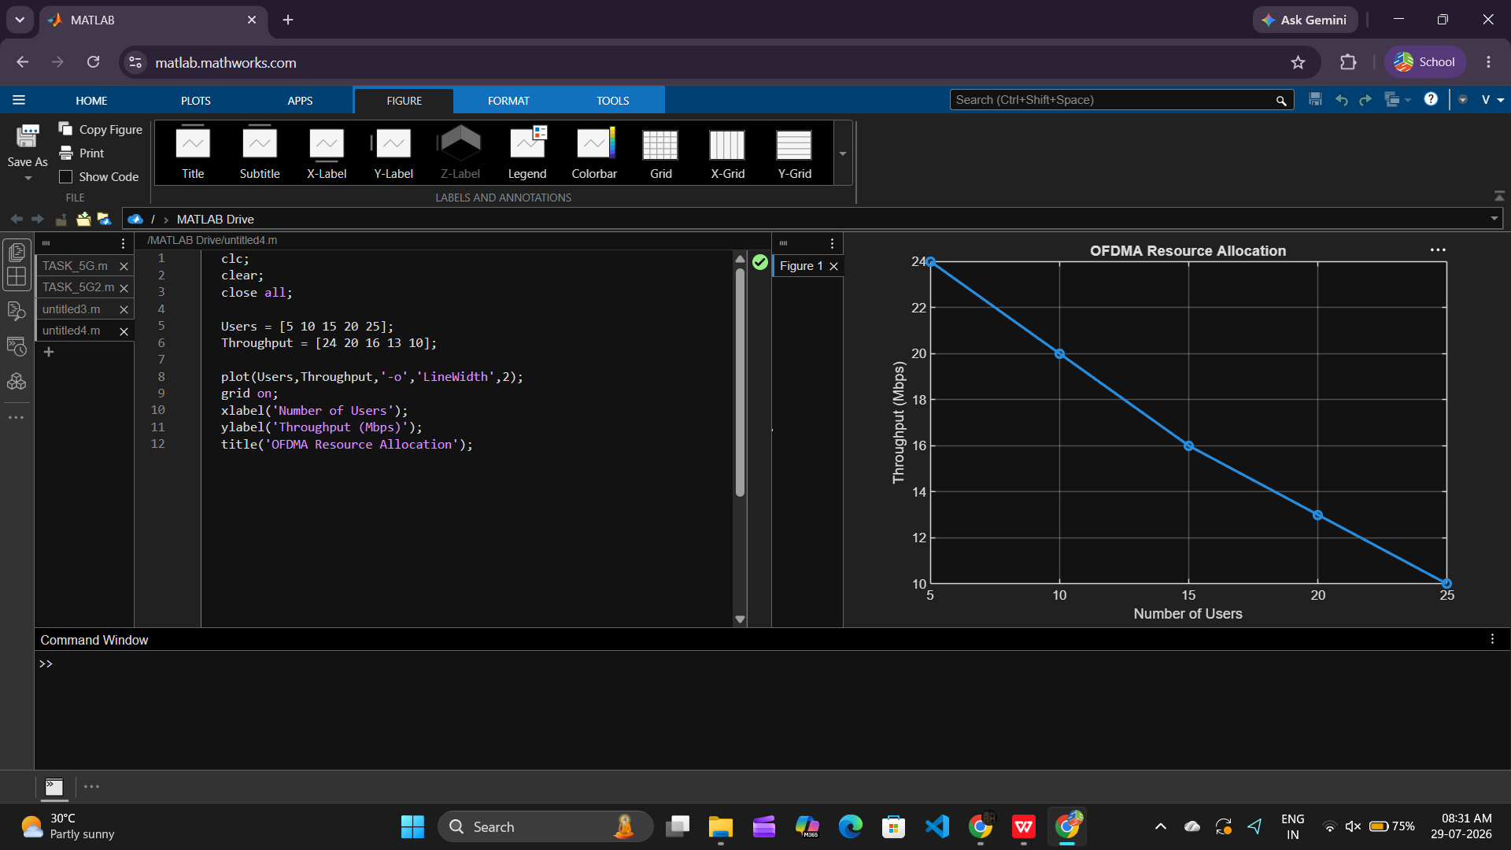

Result :- As the number of users increased, the throughput per user decreased due to shared subcarrier allocation.

Question 17:Simulation of Subcarrier Spacing Effect under 15 kHz, 30 kHz, 60 kHz, 120 kHz, and Symbol Duration

Objective : To simulate the effect of different subcarrier spacings on symbol duration.

Matlab Code:

clc;
clear;
close all;

SCS = [15 30 60 120];
Ts = 1./(SCS*1000);

bar(SCS,Ts*1e6);
grid on;
xlabel('Subcarrier Spacing (kHz)');
ylabel('Symbol Duration (\mus)');
title('Subcarrier Spacing vs Symbol Duration');

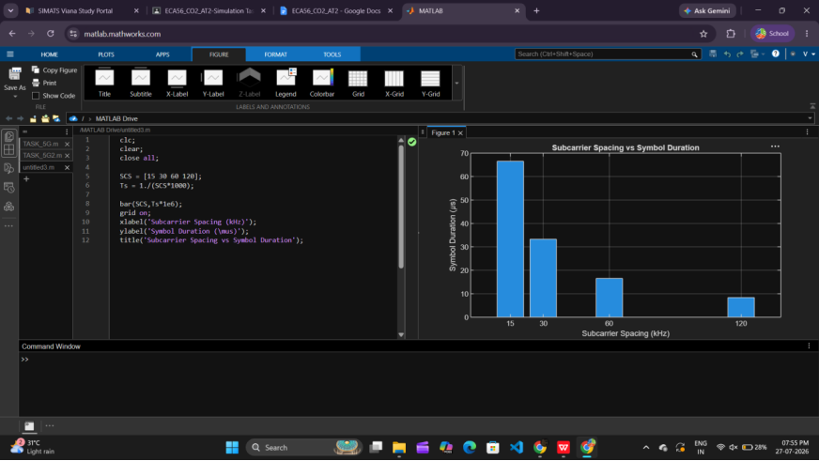

Result :- The symbol duration decreased as the subcarrier spacing increased, reducing transmission latency.

Question 19:Simulation of Waveform Comparison between LTE OFDM and 5G NR under PAPR, BER, Bandwidth, Latency, and Spectral Efficiency

Objective : To compare LTE OFDM and 5G NR waveforms based on spectral efficiency.

Matlab Code:

clc;
clear;
close all;
Tech = categorical({'LTE OFDM','5G NR'});
Efficiency = [4.5 7.2];
bar(Tech,Efficiency);
grid on;
ylabel('Spectral Efficiency (bits/s/Hz)');
title('LTE OFDM vs 5G NR');

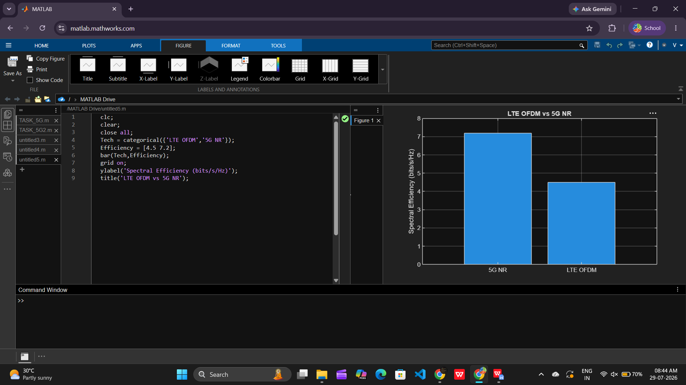

Result :- The symbol duration decreased as the subcarrier spacing increased, reducing transmission latency.

